No. | Answer
Analgesic: pain reliever
Antipyretic: reduces fever
Anti-inflammatory: reduces production of prostaglandins that lead to inflammation
 | Used by the ancient Greeks and by native Americans, who chewed the leaves.
a Carboxylic acid
b Hydroxy (or alcohol)
c Ester
 | 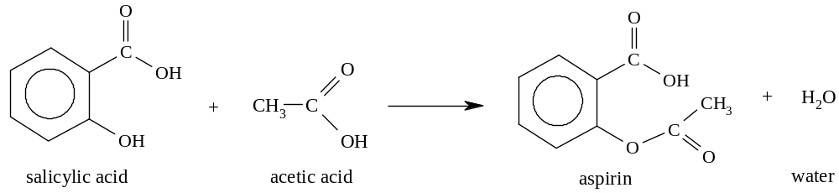
 | 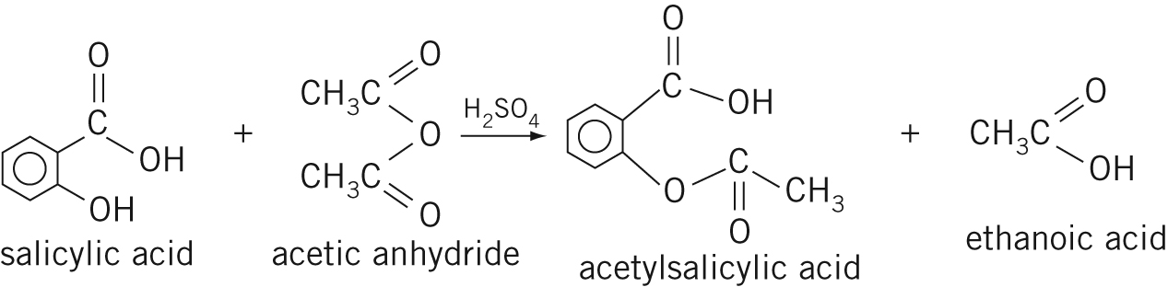
a It is a catalyst.
b It is used in many ester-forming reactions.
a The binder holds the tablet together so that it is a single, solid tablet.
b The binder must be harmless, stable and edible – starch is suitable for this.
a m(acetylsalicylic acid) = 0.325 × 10⁶ mg = 325 × 10³ g
n(acetylsalicylic acid) = 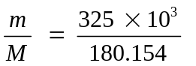
n(salicylic acid) = n(acetylsalicylic acid)
= n × M = 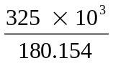 × 138 = 249 × 10³ g = 249 kg
b The process is far from 100% efficient. Reaction is incomplete and isolation of the product is difficult because the solubility of the aspirin makes it hard to crystallise out from the reaction solution.
 | Stomach bleeding may occur. In addition, the blood is thinned too much, making it unlikely to congeal and so interfering with the clotting process.
Methyl salicylate (oil of wintergreen) is produced.

